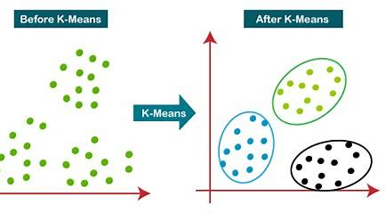

The K-Means algorithm is a popular clustering method that groups data points into distinct clusters.

1. **Choose K**: First, you decide how many clusters (K) you want to create.
2. **Pick Starting Points**: You randomly select K points, which will act as the initial centers (centroids) for the clusters.
3. **Assign Points to Clusters**: Each data point is then assigned to the nearest centroid, forming K clusters based on proximity.
4. **Update Centroids**: After grouping, you calculate the average position of all the points in each cluster and place a new centroid in that location.
5. **Reassign Points**: You repeat the process of assigning each point to its nearest new centroid.
6. **Repeat Until Stable**: If points keep moving to different clusters, steps 4 and 5 are repeated. Once no points change clusters, the algorithm finishes.

In the end, the data is grouped into clusters, and each group has a centroid representing its center.